DEPARTMENT OF ZOOLOGY DATE: 15.12.2023
FIELD VISIT TO NEARBY FISH TANKS
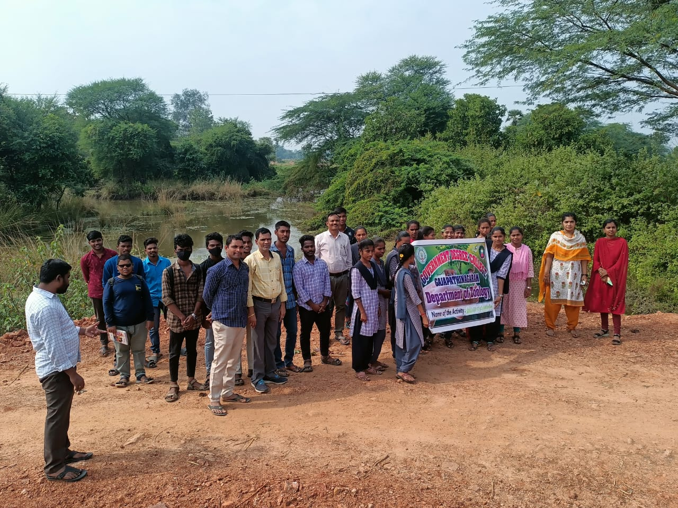
No of Students Participated: 24
No of Lecturers Participated: 06

DEPARTMENT OF ZOOLOGY DATE: 13.02.2025
FIELD VISIT TO FISH CULTURE PONDS AT PSR PURAM VILLAGE
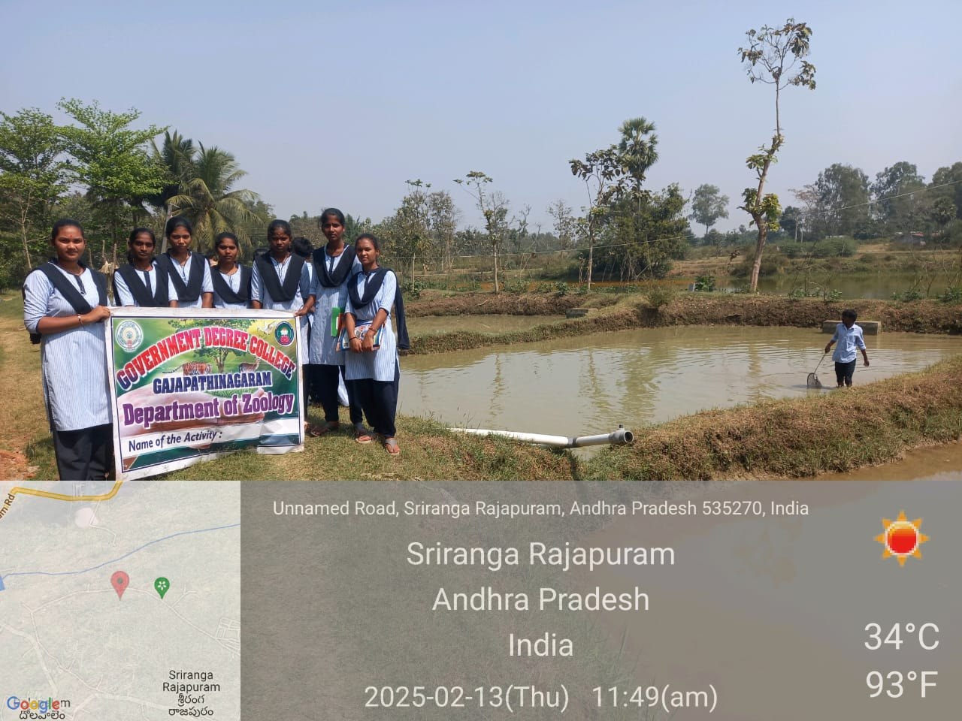
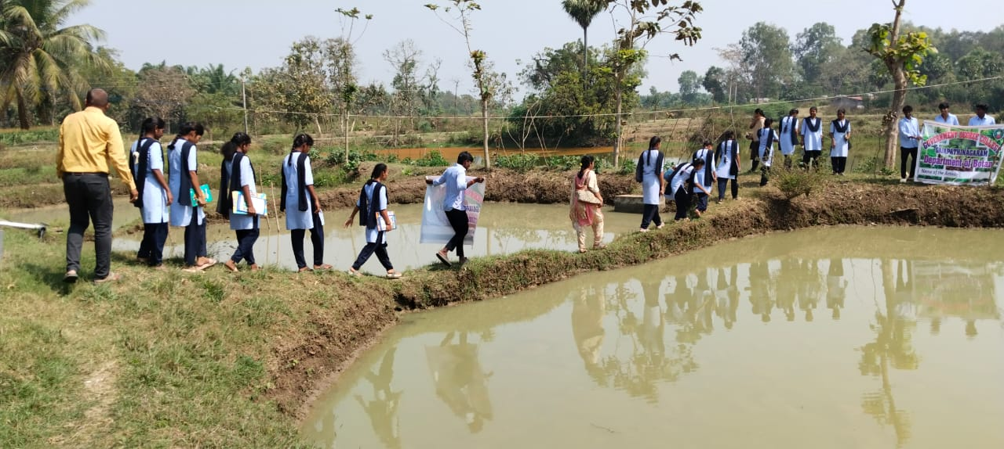
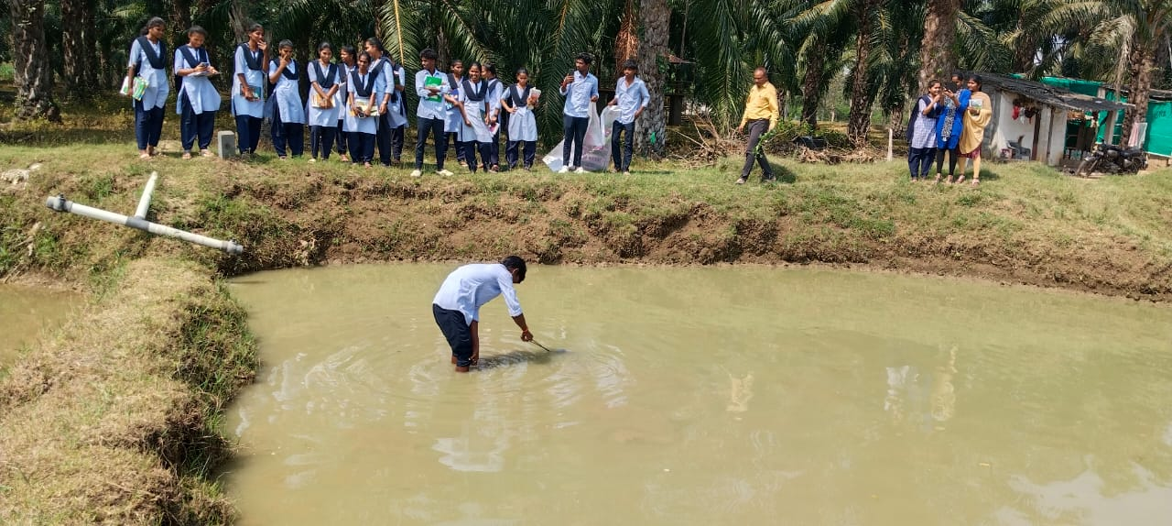
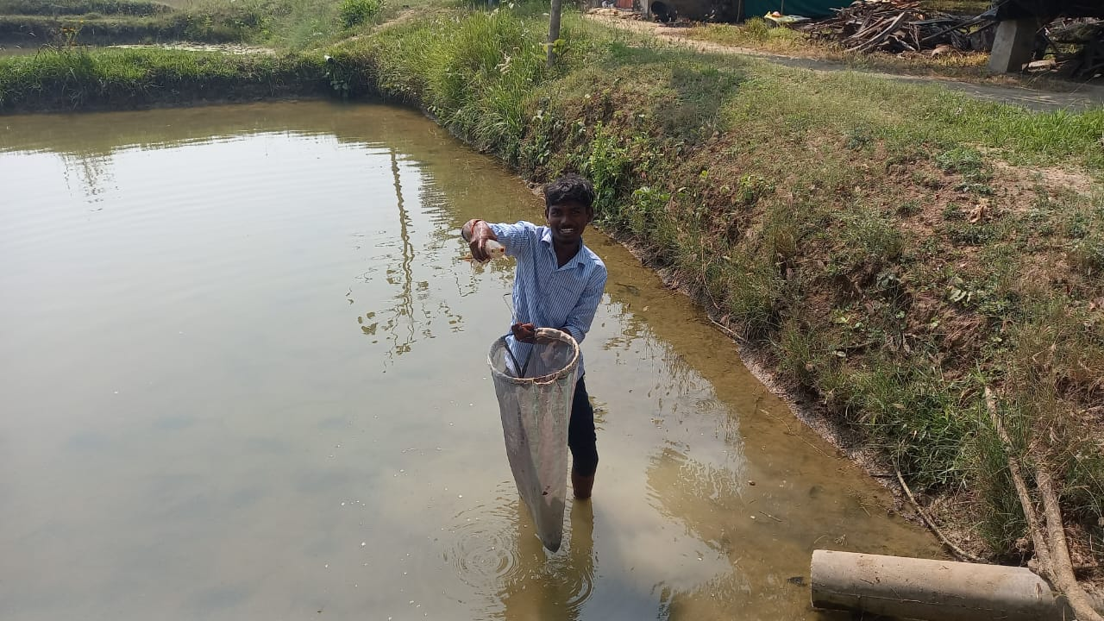
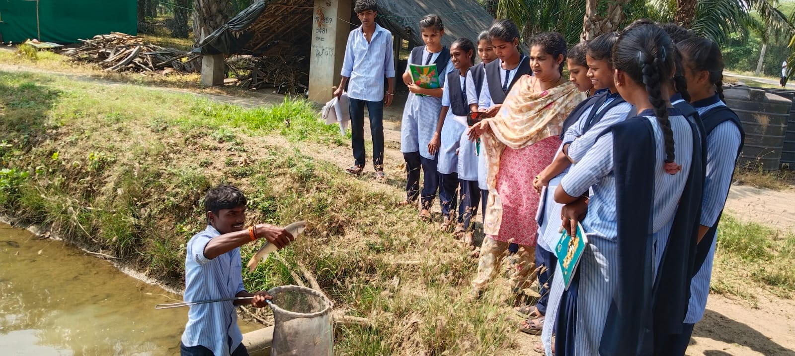
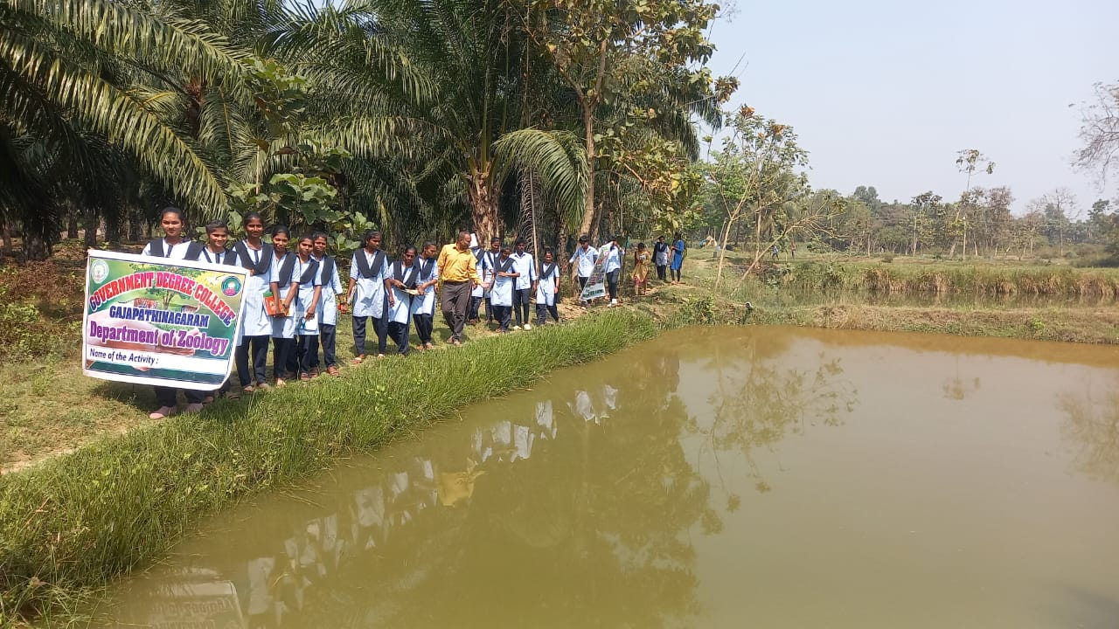
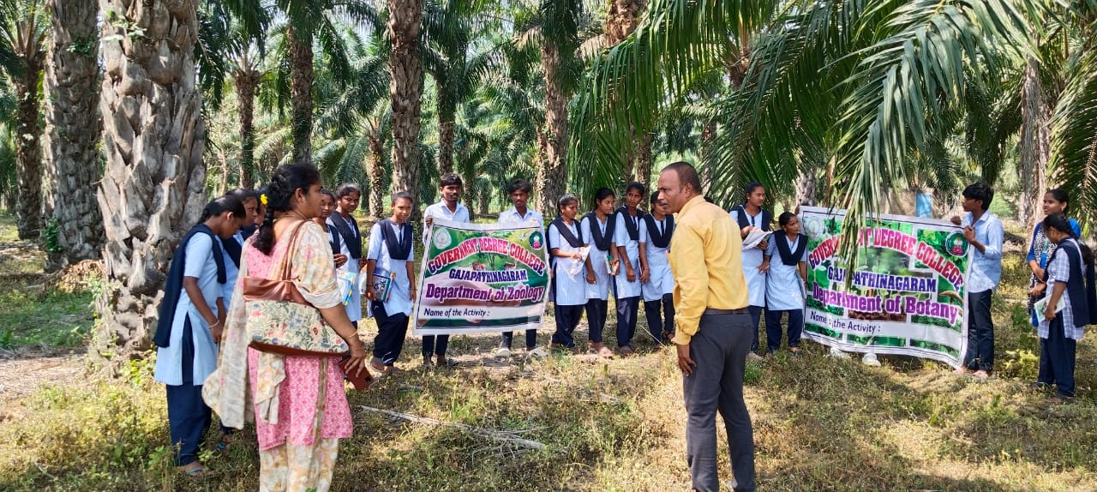
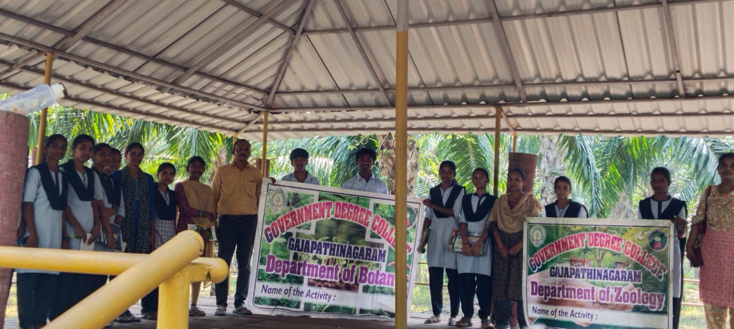
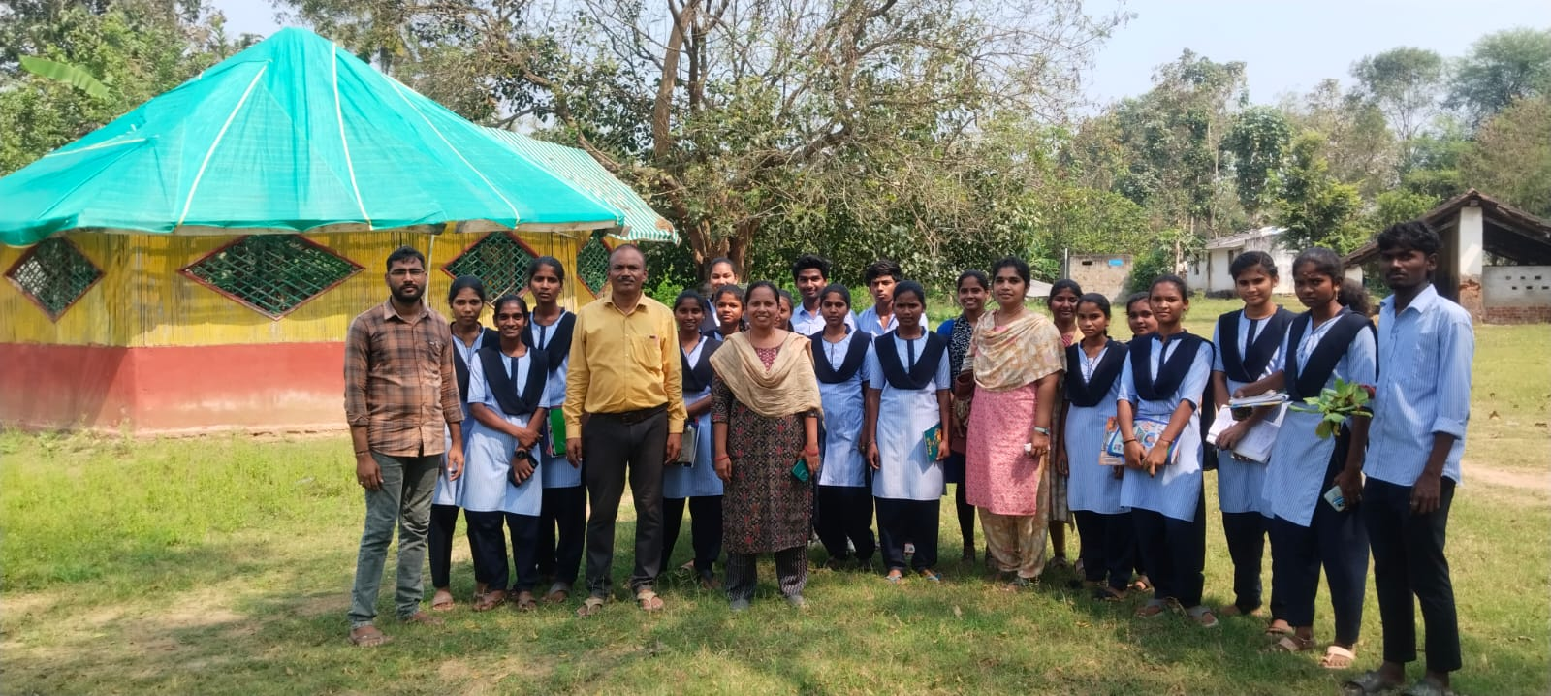
VISIT TO THE POULTRY FARM AT PSR PURAM
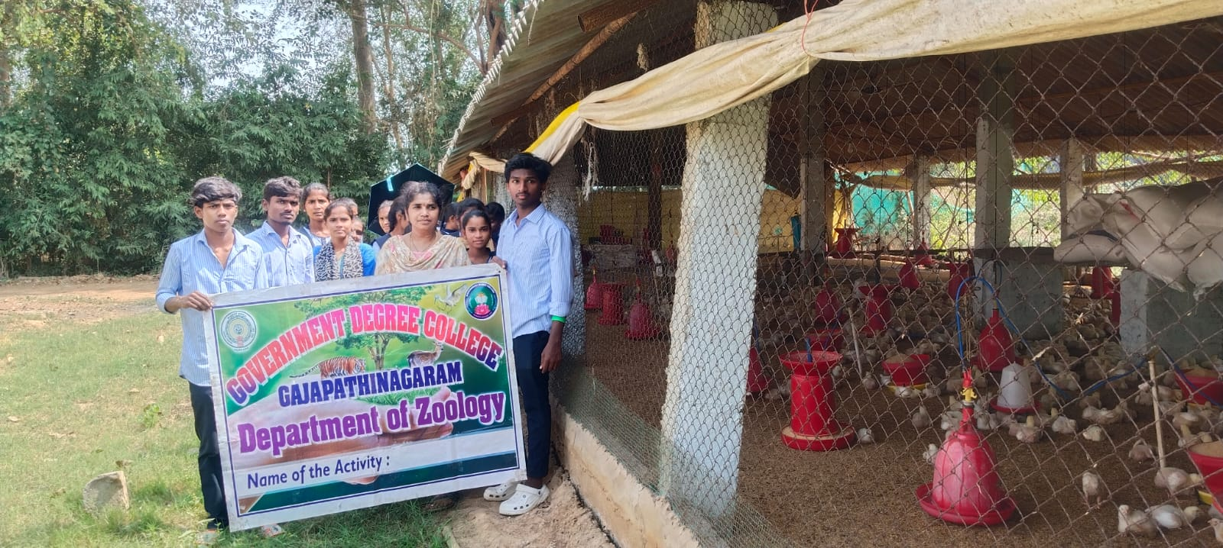
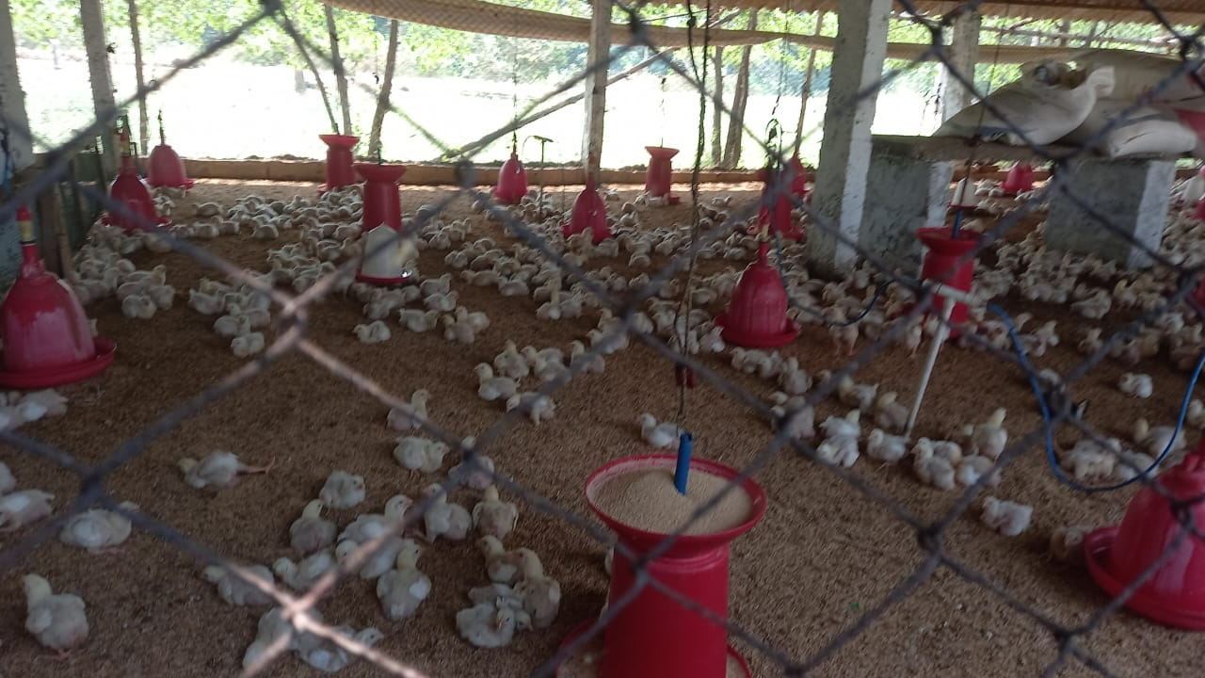
NO OF STUDENTS PARTICIPATED: 28
NO OF LECTURERS PARTICIPATED: 04

